**Pizza Sales SQL Queries**

**A.KPI’s**

**1. Total_Revenue:**

Select round(sum(total_price),1) as Total_Revenue from pizza_sales

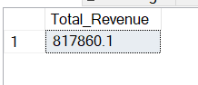

**2. Average_Order_Value:**

Select SUM(total_price)/count(DISTINCT order_id) as Average_Order_Value from pizza_sales

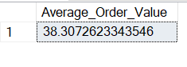

**3. Total_Pizza_Sold:**

Select sum(quantity) as Total_Pizza_Sold from pizza_sales

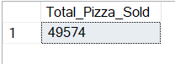

**4. Total_Orders:**

Select count(DISTINCT order_id) as Total_Orders from pizza_sales

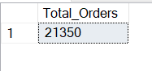

**5. Avg_Pizza_Per_Order:**

Select CAST(CAST(COUNT(pizza_id)as DECIMAL(10,2))/CAST(Count(Distinct order_id)

As DECIMAL(10,2)) as DECIMAL(10,2)) as Avg_Pizza_Per_Order from pizza_sales

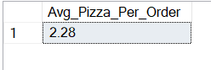

**B. CHARTS**

**1. Total_Order_Per_Day:**

Select DATENAME(DW, order_date) as Day , count(distinct order_id) as total_Orders from pizza_sales

group by DATENAME(DW, order_date)

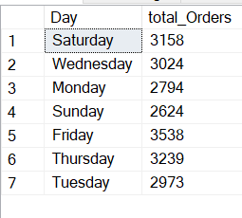

**2. Total_Orders_Per_Month:**

Select DATENAME(Month, order_date) as Month, COUNT(DISTINCT order_id) as total_orders from pizza_sales group by DATENAME(Month, order_date)

order by total_orders DESC

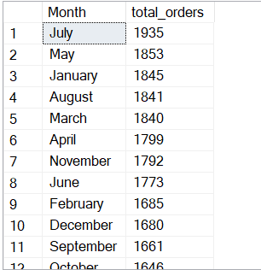

**3. Percentage_Per_Category:**

Select pizza_category, ROUND(SUM(total_price)*100 /(Select sum(total_price) from pizza_sales),2) as Per_Total_Sales

from pizza_sales

group by pizza_category

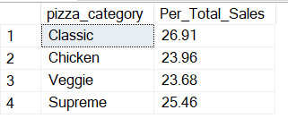

**4. Percentage_Per_Pizza_Size:**

Select pizza_size,ROUND(SUM(total_price)*100 /(Select sum(total_price) from pizza_sales),2) as Per_Total_Sales

from pizza_sales

group by pizza_size

order by Per_Total_Sales DESC

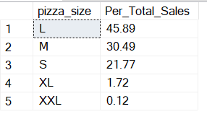

**5. Top_5_By_Revenue:**

Select top 5 pizza_name as name, sum(total_price) as total_price from pizza_sales

group by pizza_name

order by total_price DESC

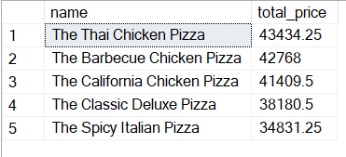

**6. Bottom_5_By_Revenue:**

Select top 5 pizza_name as name, ROUND(sum(total_price),2) as total_price from pizza_sales

group by pizza_name

order by total_price ASC

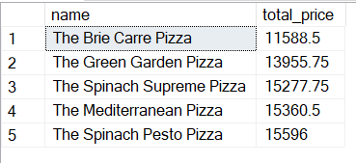

**7. Top_5_By_Quantity:**

Select top 5 pizza_name as name, sum(quantity) as total_price from pizza_sales

group by pizza_name

order by total_price DESC

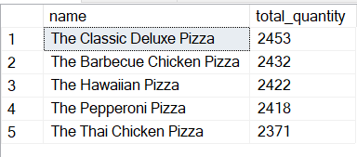

**8. Bottom_5_By_Quantity:**

Select top 5 pizza_name as name, sum(quantity) as total_price from pizza_sales

group by pizza_name

order by total_price ASC

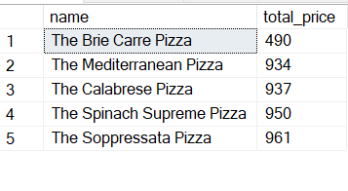

**9. Top_5_By_Orders:**

Select top 5 pizza_name as name, count(Distinct order_id) as total_order from pizza_sales

group by pizza_name

order by total_order DESC

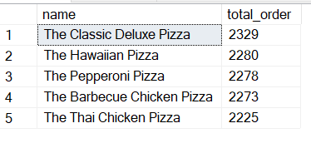

**10. Bottom_5_By_Order:**

Select top 5 pizza_name as name, count(Distinct order_id) as total_order from pizza_sales

group by pizza_name

order by total_order ASC

